**ELECTRIC VEHICLES MARKET**

Market segmentation

BATTALA RADHIKA

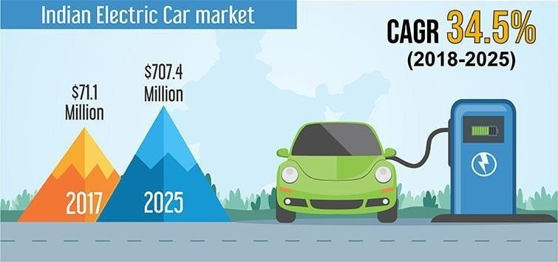

Abstract:

Market segmentation becomes a crucial tool for evolving transportation technology

such as electric vehicles (EVs) in emerging markets to explore and implement for extensive adoption. EVs adoption is expected to grow phenomenally in near future

as low emission and low operating cost vehicle, and thus, it drives a considerable amount of forthcoming academic research curiosity. The main aim of this study is to explore and identify distinct sets of potential buyer segments for EVs based on *psychographic, behavioral, and socio-economic* characterization by employing an integrated research framework of *‘perceived benefits-attitude-intention’*. The study applied robust analytical procedures including cluster analysis, multiple discriminant analysis and Chi-square test to operationalize and validate segments from the data collected of 563 respondents using a cross-sectional online survey. The findings posit that the three distinct sets of young consumer groups have been identified and labelled as *‘Conservatives’, ‘Indifferents’, and ‘Enthusiasts’* which are deemed to be buddying EV buyers The implications are recommended, which may offer some pertinent guidance for scholars and policy makers to encourage EVs adoption in the backdrop of emerging sustainable transport market. In this report we are going to analyse the data and solve the problem using **Fermi**

**Estimation** by breaking down the problem.

**KeyWords** : *Electric vehicles, Market segmentation, Cluster analysis, Attitude to*

*wards electric vehicles, Subjective norms, Adoption intention, Sustainable transporta*ction.

**What is Electric Vehicle?**

An EV is a shortened acronym for an electric vehicle. EVs are vehicles that are either partially or fully powered on electric power. Electric vehicles have low running costs as they have less moving parts for maintaining and also very environmentally friendly as they use little or no fossil fuels (petrol or diesel).

While some EVs used lead acid or nickel metal hydride batteries, the standard for modern battery electric vehicles is now considered to be lithium ion batteries as they have a greater longevity and are excellent at retaining energy, with a selfdischarge rate of just 5% per month. Despite this improved efficiency, there are still challenges with these batteries as they can experience thermal runaway, which have, for example, caused fires or explosions in the Tesla model S, although efforts have been made to improve the safety of these batteries.

## Working principle

An electric vehicle works on a basic principle of science: **conversion of energy**. Electrical energy is converted into mechanical energy. There is a motor used in the electrical system to carry on this duty of conversion. Motors can be of various types.

**Data Collection**

The data has been collected manually, and the sources used for this process are listed

below :

• https://www.kaggle.com/datasets

• https://data.gov.in/

• https://www.data.gov/

**Market Segmentation**

**Target Market:**

The target market of Electric Vehicle Market Segmentation can be categorized into Geographic, SocioDemographic, Behavioral, and Psychographic Segmentation.

**Behavioral Segmentation:** searches directly for similarities in behavior or reported behavior.

Example: prior experience with the product, amount spent on the purchase, etc.

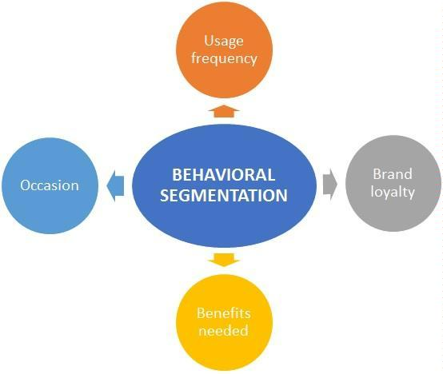

Figure 1: *Behavioral Segmentation*

**Advantage:** uses the very behavior of interest is used as the basis of segment extraction.

**Disadvantage:** not always readily available.

**Psychographic Segmentation:** grouped based on beliefs, interests, preferences, aspi rations, or benefits sought when purchasing a product. Suitable for lifestyle segmentation.involve many segmentation variables.

**Advantage:** generally more reflective of the underlying reasons for differences in consumer behavior.

**Disadvantage:** increased complexity of determining segment memberships for consumers.

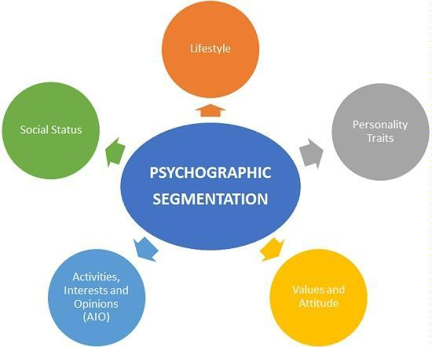

Figure 2: *Psychographic Segmentation*

**Socio-Demographic Segmentation:** includes age, gender, income and education.

Useful in industries

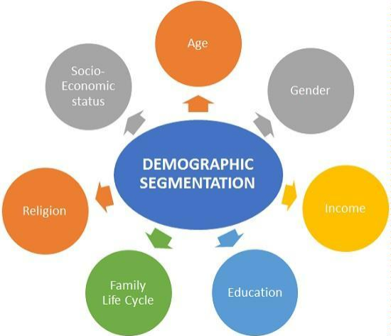

Figure 3: *Behavioral Segmentation*

**Advantage:** segment membership can easily be determined for every customer.

**Disadvantage:** if this criteria is not the cause for customers product preferences then

it does not provide sufficient market insight for optimal segmentation decisions.

**Segmenting for Electric Vehicle Market**

The market segmentation approach aims at defining actionable, manageable, homogenous subgroups of individual customers to whom the marketers can target with a similar set of marketing strategies. In practice, there are two ways of segmenting the market-a-priori and post-hoc. An a-priori approach utilizes predefined characteristics such as age, gender, income, education, etc. to predefine the segments followed by pro filing based on a host of measured variables *(behavioral, psychographic or benefit)*. In the post-hoc approach to segmentation on other hand, the segments are identified based on the relationship among the multiple measured variables. The commonality between both approaches lies in the fact that the measured variables determine the *‘segmentation theme’*. The present study utilizes an a-priori approach to segmentation o as to divide the potential EV customers into sub-groups.

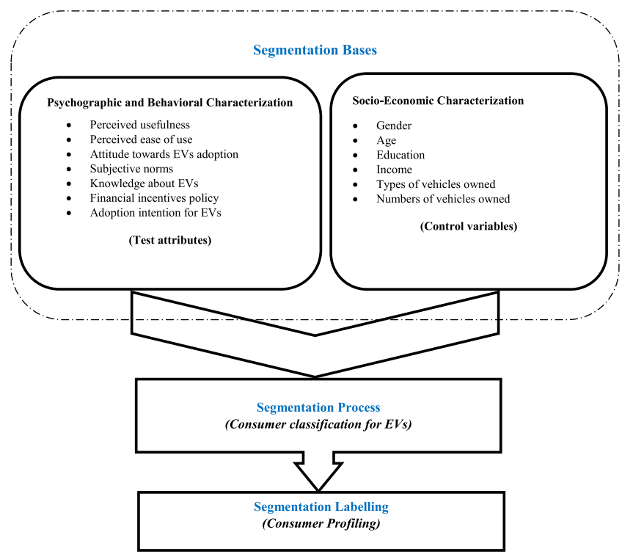

Figure 4: *Market Segmentation Electric Vehicles*

It is argued that the blended approach of *psychographic* and *socioeconomic attributes* for market segmentation enables the formulation of sub-market strategies which inturn satisfy the specific tastes and preferences of the consumer groups. Straughan and Roberts presented a comparison between the usefulness of *psychographic, demographic, and economic* characteristics based on consumer evalua tion for eco-friendly products.

They pinpointed the perceived superiority of the psychographic characteristics in profiling the consumer segments in the market for eco-friendly products. The present study adds perceived-benefit characteristics guided by blended psychographic and socio-economic aspects for segmenting the consumer market.

# Code Implementation

**Packages/Tools used:**

1. **Numpy:** To calculate various calculations related to arrays.

2. **Pandas:** To read or load the datasets.

3. **SKLearn:** We have used LabelEncoder() to encode our values.

## Importing Necessary Libraries

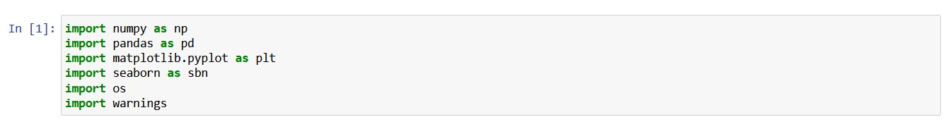

**Fig 1:** Importing Libraries for Code Implementation

1. NumPy is a Python library used for working with arrays. It also has functions for working in domain of linear algebra, fourier transform, and matrices.
2. Pandas is a library written for the Python programming language for data manipulation and analysis
3. Matplotlib is one of the most popular Python packages used for data visualization. It is a cross-platform library for making 2D plots from data in arrays.
4. Seaborn is an open-source Python library built on top of matplotlib. It is used for data visualization and exploratory data analysis.
5. Warnings are provided to warn the developer of situations that aren’t necessarily exceptions

## Reading Data

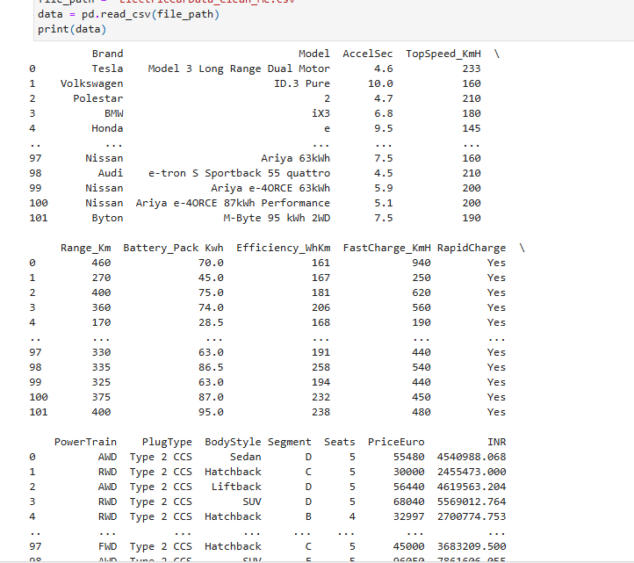

**Fig 2:** Dataset used for Code Implementation

## Analysing the Dataset

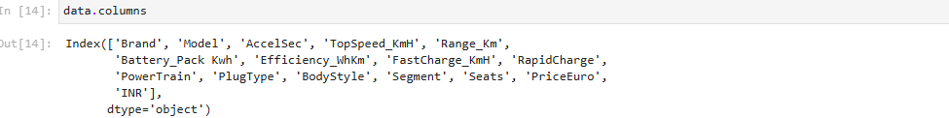

**Fig 3:** columns of the Data set



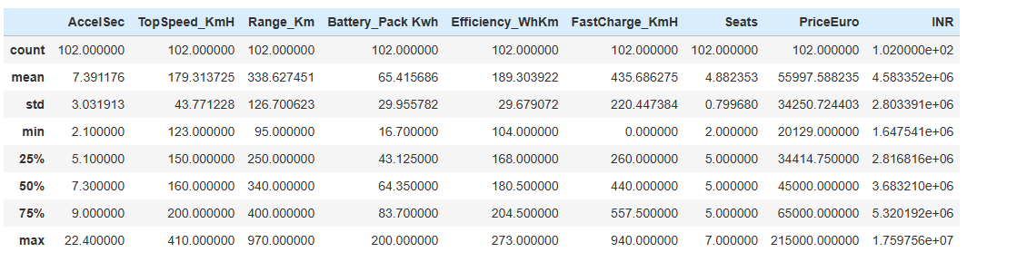

**Fig 4:** Information

## Checking for Null values in the dataset

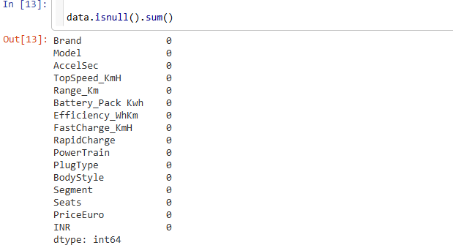

**Fig 5:** Checking for the null values in the Data set

## Visualization

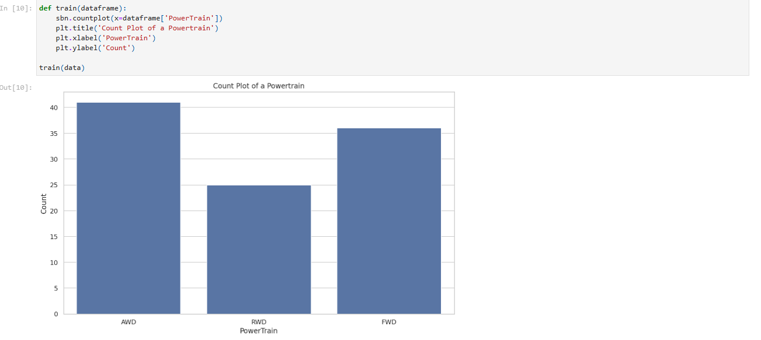

**Fig 6:** Count Plot of a Powertrain

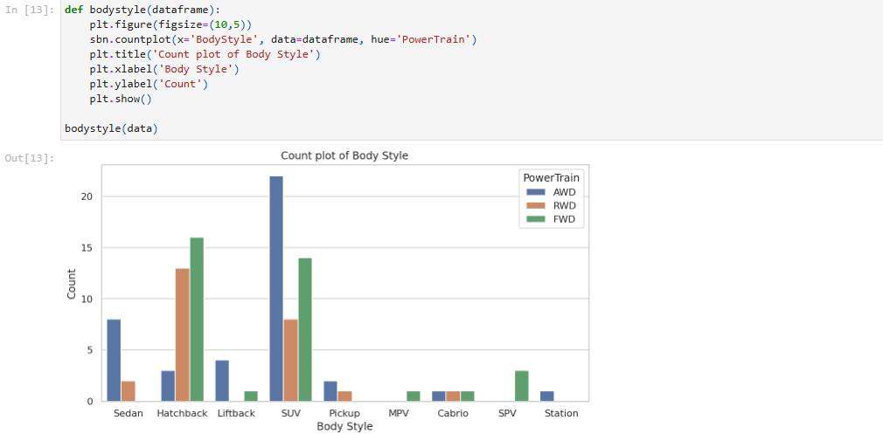

**Fig 7:** Count plot of body Style of the cars

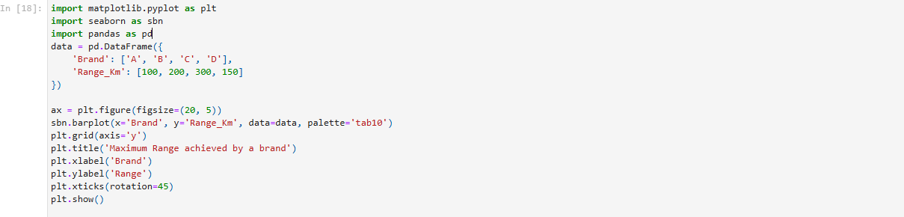

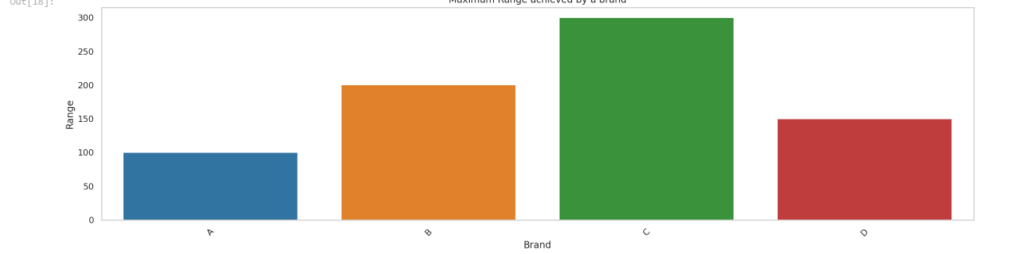

**Fig 8:** Bar graph of Range of EV’s

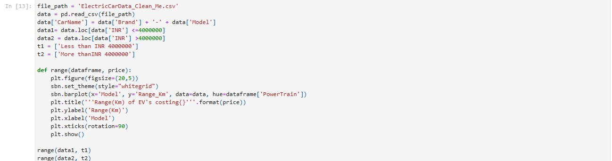

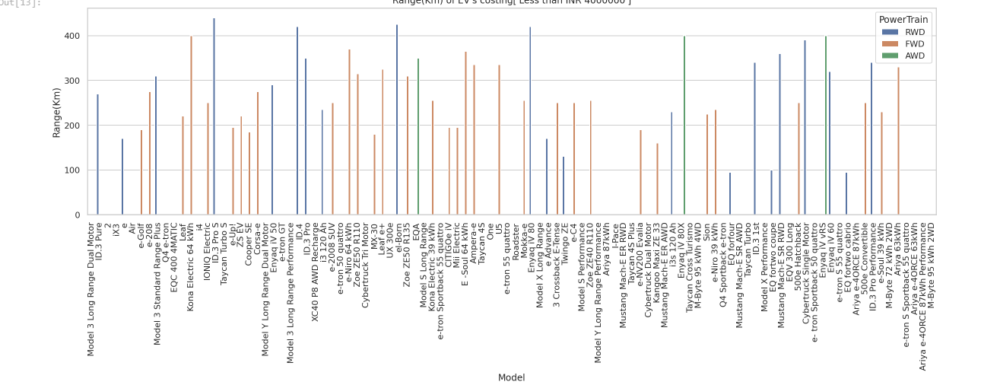

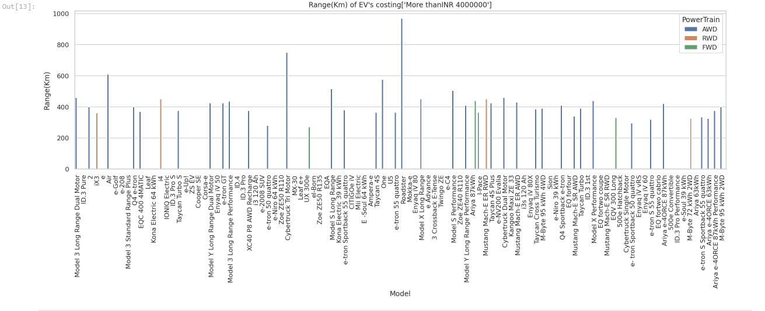

**Fig 9:** Bar graph of Range of EV’S

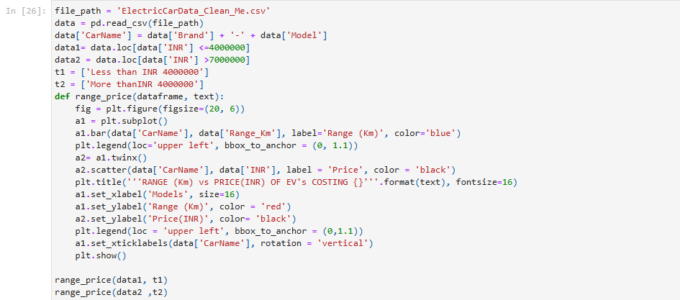

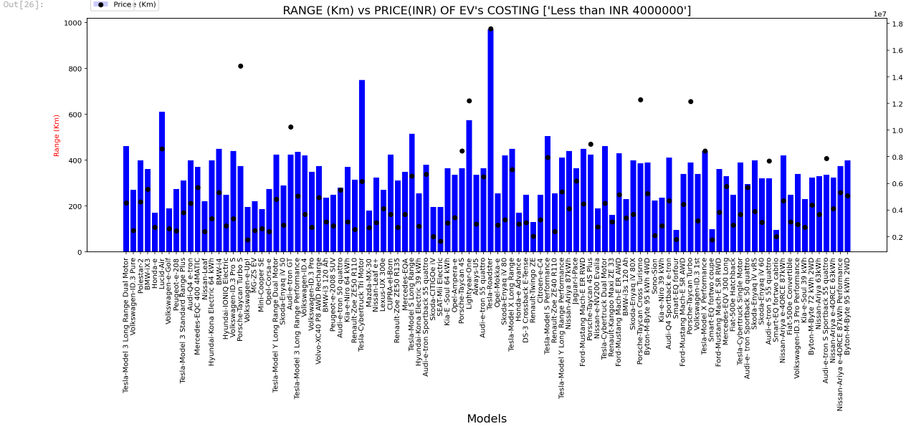

**Fig 10:** Bar graph of Range vs Price of EV’s

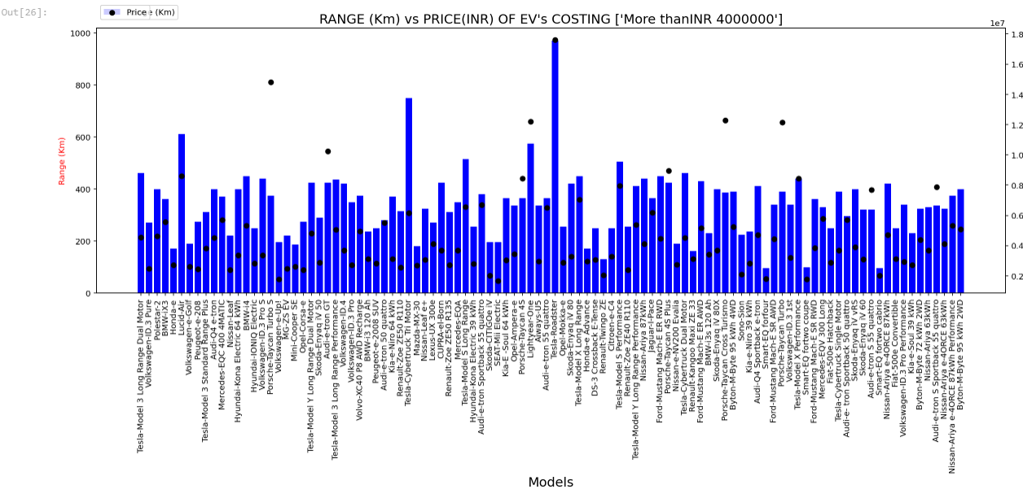

**Fig 11:** Bar graph of Range vs Price of EV’s

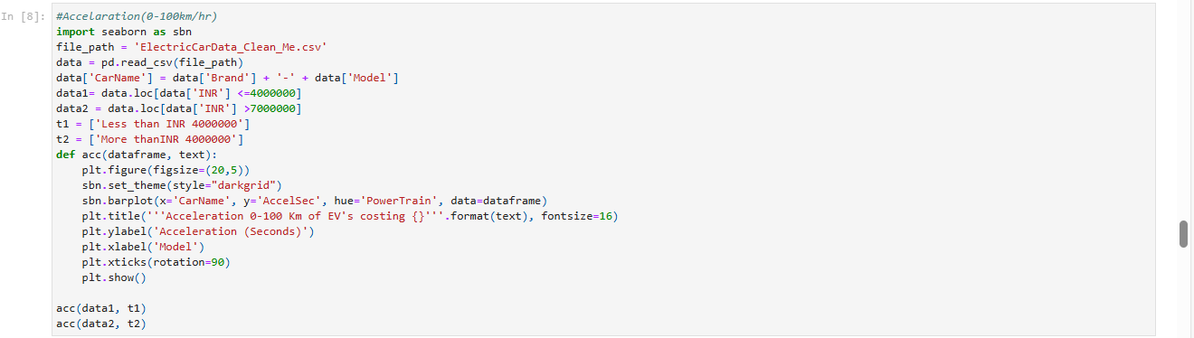

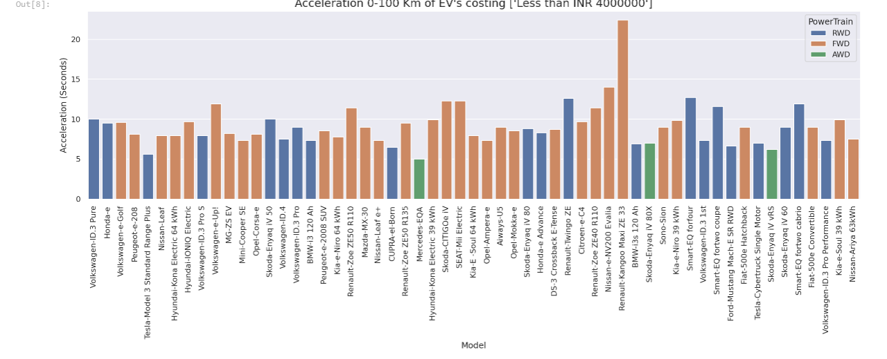

**Fig 12:** Bar graph of Acceleration vs Price of EV’s

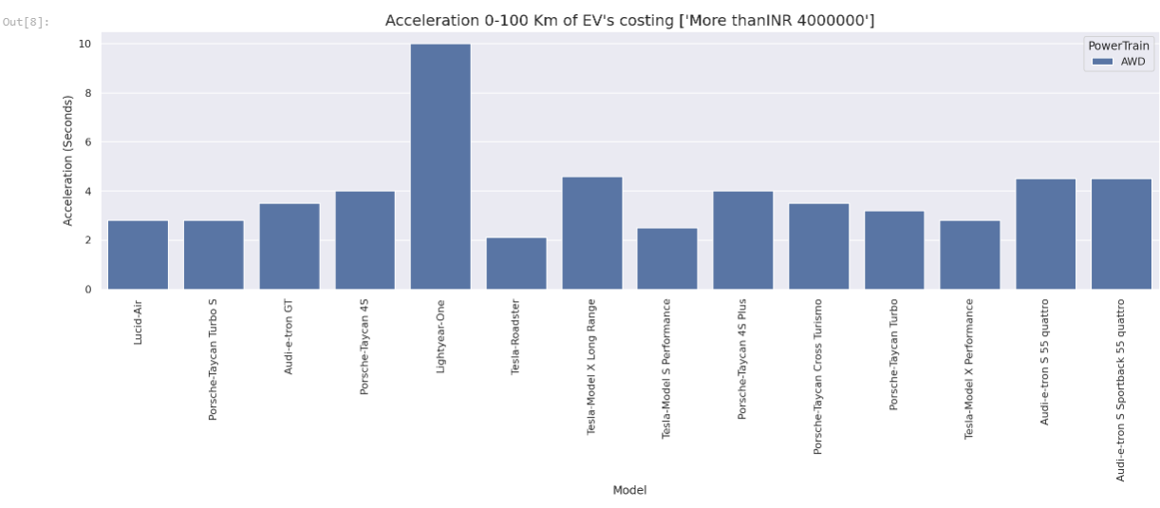

**Fig 13:** Bar graph of Acceleration vs Price of EV’s

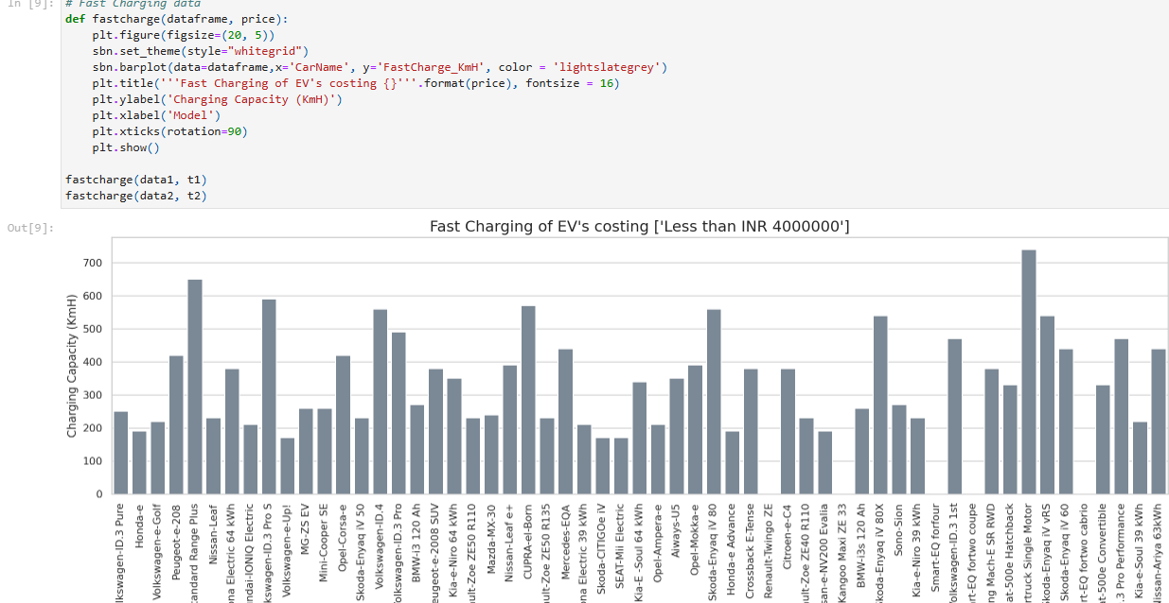

**Fig 14:** Bar graph of Fast Charging ability of EV’

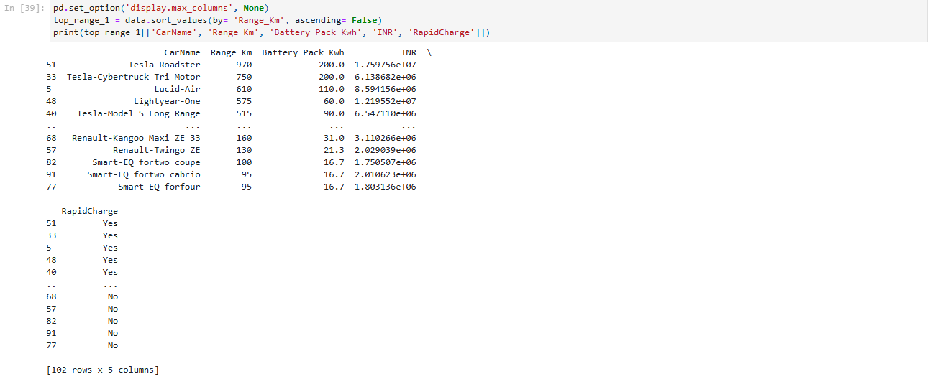

**Fig 15:** Vehicles to buy under INR 40,00000

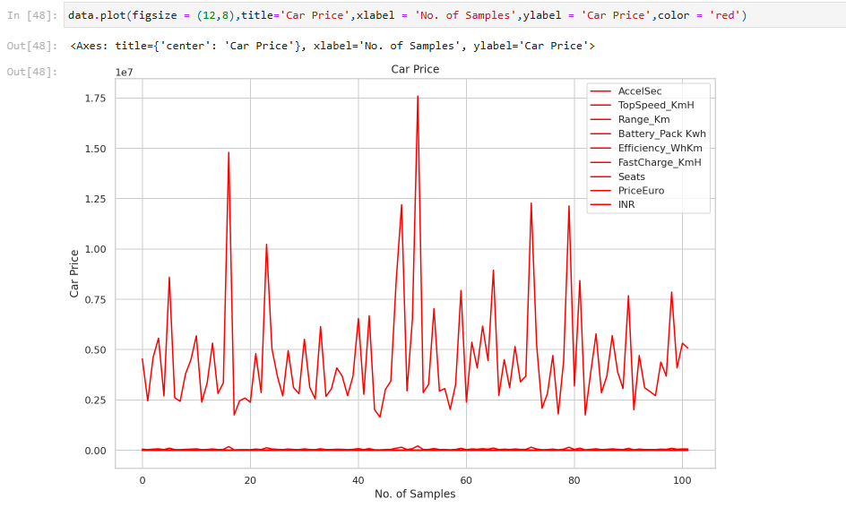

Figure 16: Car price

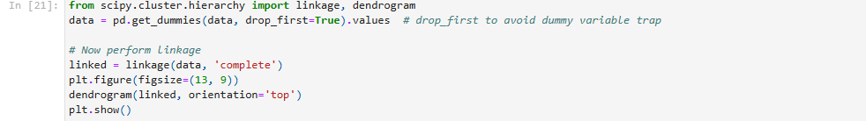

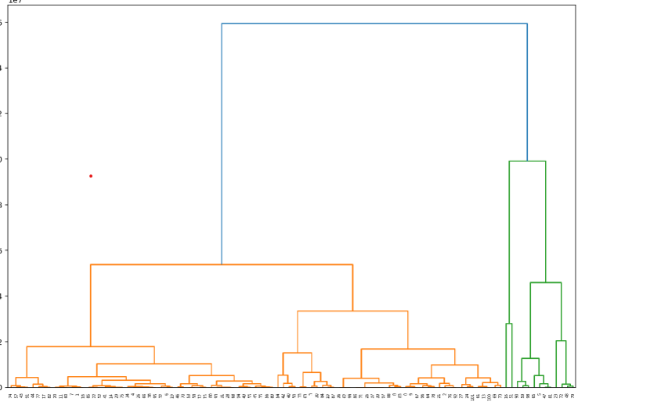

Figure 17: *Dendrogram Plot for our Dataset*

State wise Pollution Data Analysis

Importing Necessary Libraries

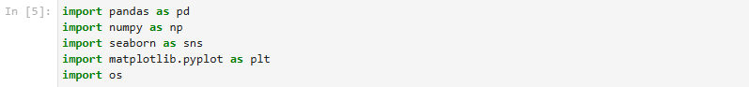

Fig 1: importing libraries

Reading the data



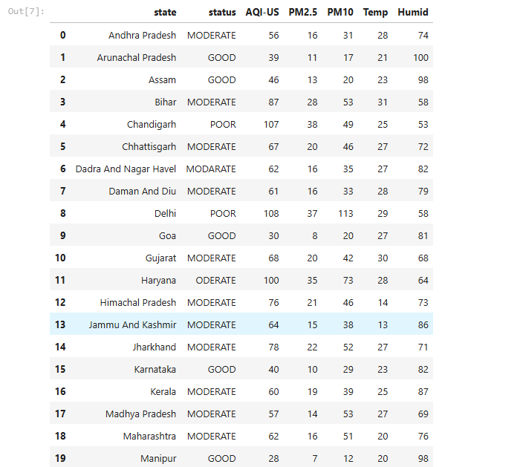

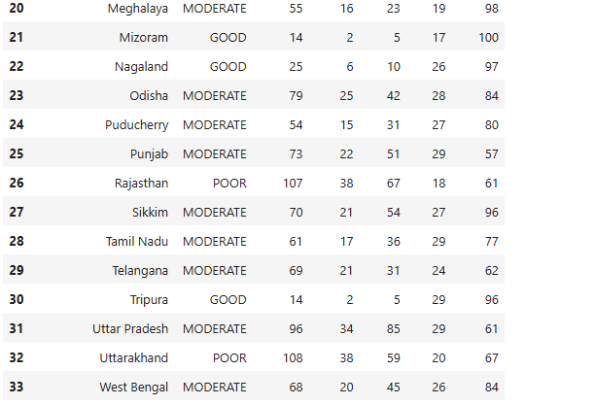

Fig2: Data set used for code implementation

Checking for null values in the data set

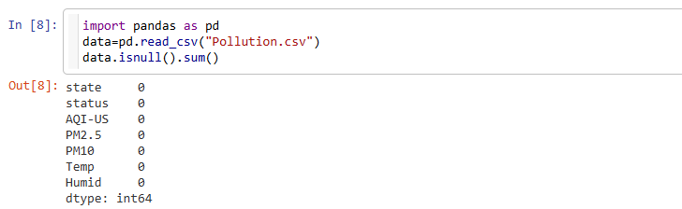

Fig3: Checking for null values in the dataset

**Analysing the data:**



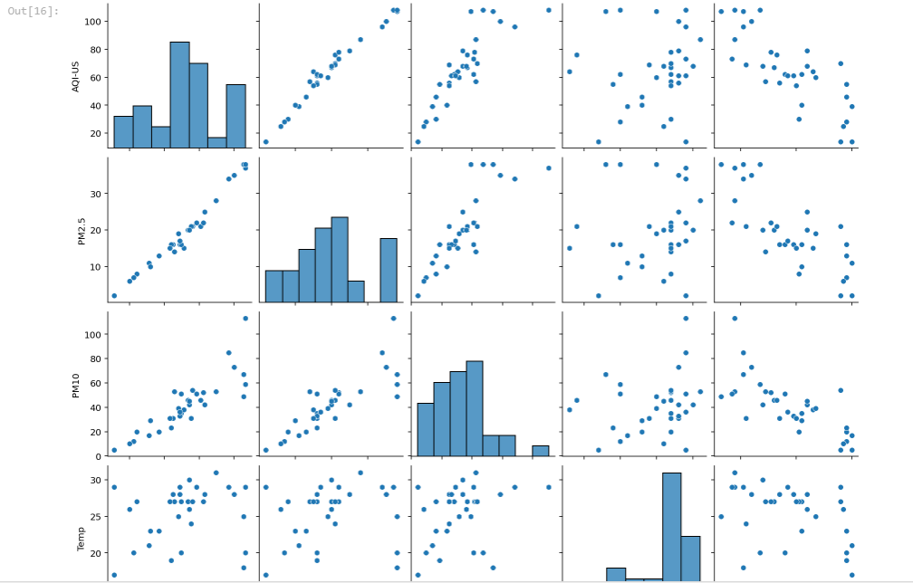

**Fig4:pairplot of data present in the data**

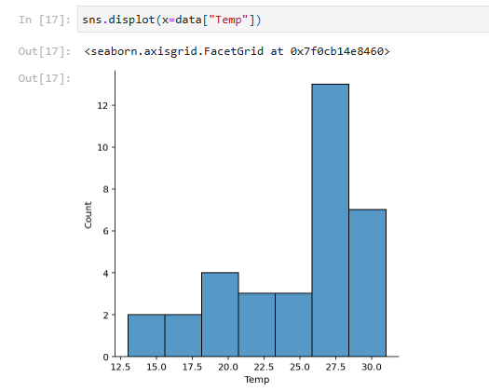

Fig5 :Displot of state wise Temparature data

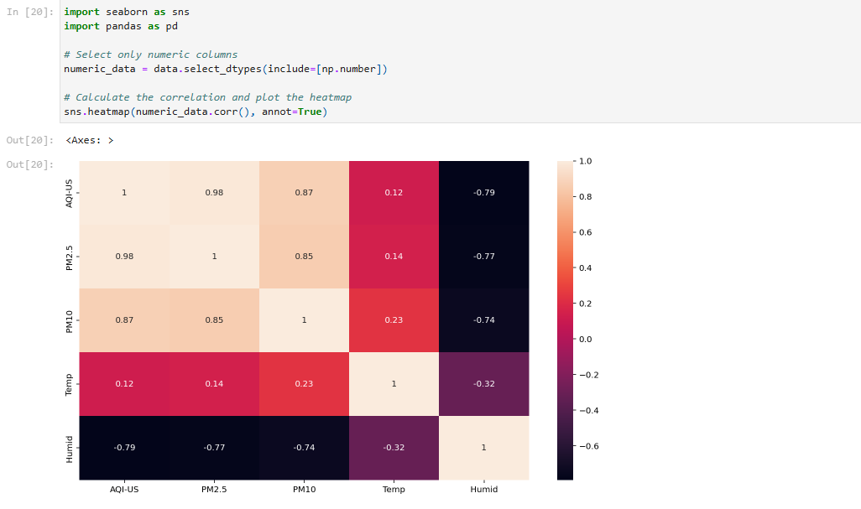

Fig6:Heat map

## 

Fig7 : Barplot

## Conclusion

Based on the above analysis and visualizations, it would be really helpful for any company which is looking to open up an EV start up in India. In this report, 4 wheeler EV’s are more concentrated, the customer space has been visualized in a detailed manner to understand the trends and move accordingly.

Git hub link: [battalaradhika/EV-Market-India.](https://github.com/battalaradhika/EV-Market-India)